Below graph is the comparison between NoMap, TreeMap, HashMap, and LinHashMap.

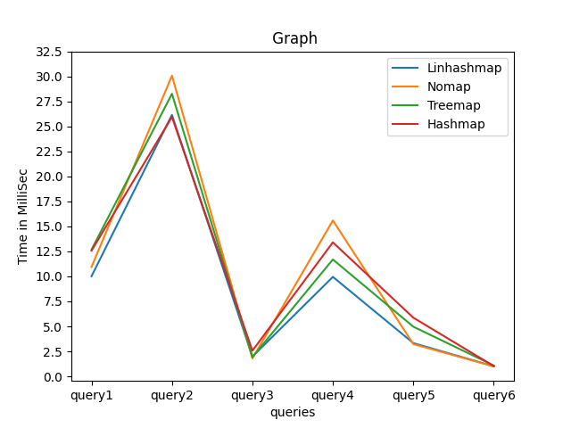

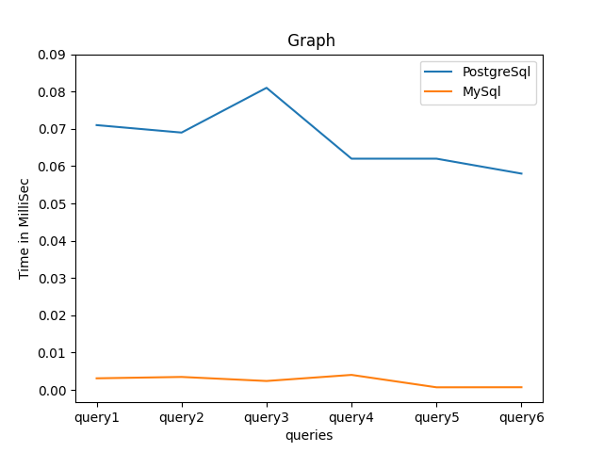

Above is the graph comparison all six queries in PostgreSQL, MySQL.

**Performace Comparision for all the queries based on Indexed and Non-indexed data accessing.**

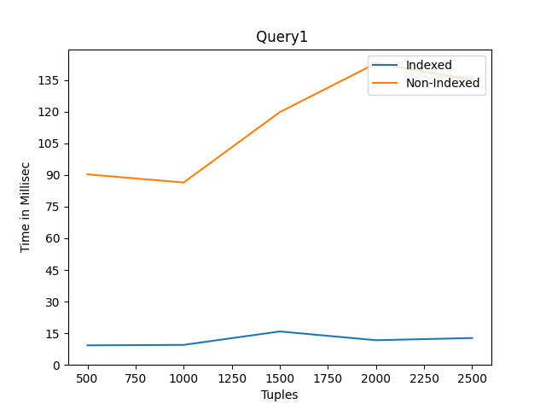

Above is the graph comparison between indexed and non-indexed join for film and film_actor table.

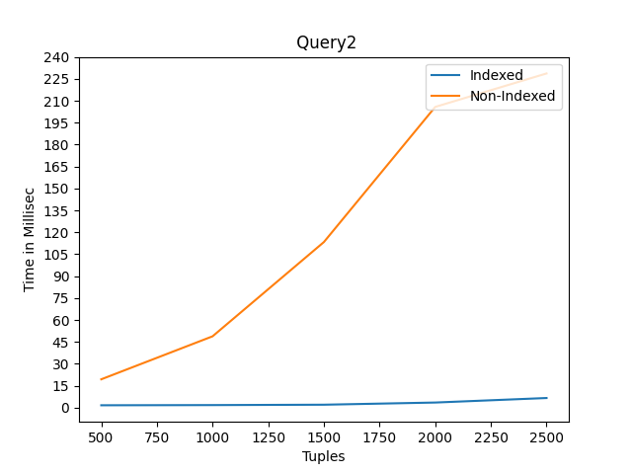

Above is the graph comparison between indexed and non-indexed join for film and rental table.

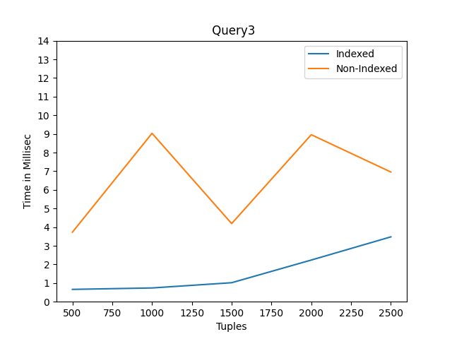

Above is the graph comparison between indexed and non-indexed join for film and film_actor and actor table.

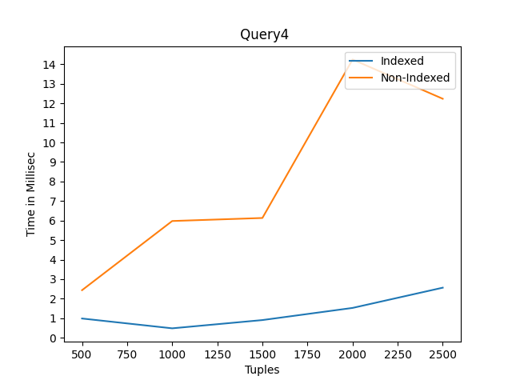

Above is the graph comparison between indexed and non-indexed join for film, rental and customer table.

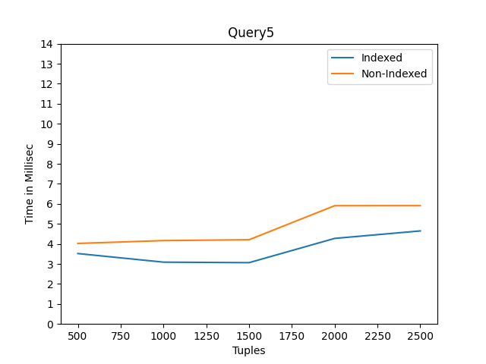

Above is the graph comparison between indexed and non-indexed select queries; selection of actor who acted in Chicago North

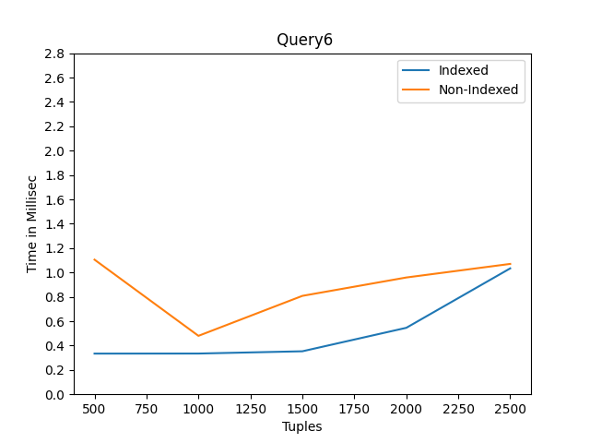

Above is the graph comparison between indexed and non-indexed select queries; customers who rented the Chicago North.